Technical Implementation:

Market Expansion and Customer Relations

Rae Burket Shoe Company

The A-Team

Helen Kim

Antara Mondal

Sophie Zhao

**Technical Implementation Summary**

Initial components to be included in our technical implementation include a globally relevant interface, user-centric interface and fluid and responsive design. One of the most important improvements as recommended by our Executive Summary is to implement a stable, functioning website. This website will evolve into a core component of the company, being the main interaction between Rae Burket Shoes and the customer.

To become more globally relevant, the website created as a technical implementation includes a general theme to be comfortable for all customers. Our language toggle in the main menu (shown below) allows an international customer to browse the website in their respective nation, creating an opportunity for customers beyond English-speaking companies to discover Rae Burket Shoes and their cause.

Our designed user-centric interface in our technical solution is easily accessible by customers. With clearly labelled menu tabs and direct navigation with our function to automatically scroll to respective areas on the homepage, customers and users are able to see what the website offers. To create a completely usable space, all the functions on the website are essential to the customer like our mission page, which describes the motivation to donate and the background behind the company and the cart, which completes purchases for the customer. We’ve included a contact list the customer can choose to add themselves to to keep up with the company and social media links as well (as seen below) as Rae Burket Shoes contact information to encourage customer feedback. The ability to reach out to the company and our platform for customer reviews demonstrates the importance of the customer in the development and mission of Rae Burket Shoes. 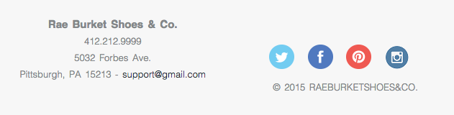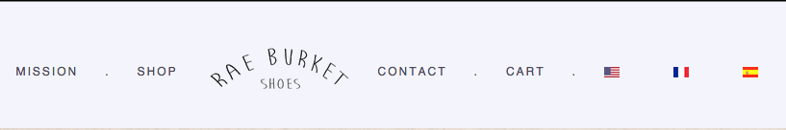

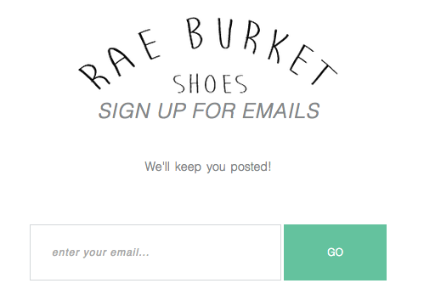

The entire website is responsive, allowing mobile and tablet users to navigate the website as easily as on a standard desktop computer. In evolving times and the present day already, browsing on-the-go has become pastime so our technical solution gives customers an opportunity to engage in Rae Burket Shoes outside of home.

Additional Features

Also included on the website is multi-generational products to appeal to younger customers as Rae Burket Shoes has already, but also to older customers with more practical shoe options versus seasonal trendy options.

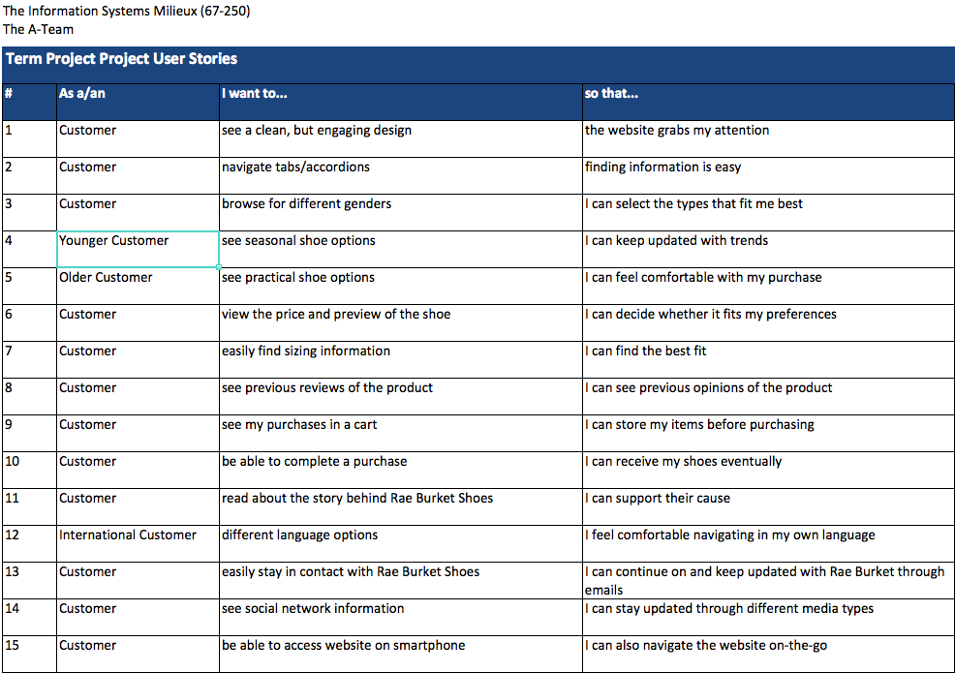**User Stories**

**Methodology**

Our implementation was created with a waterfall approach, sequentially through planning, analyzing, designing and developing phases. As a team, planning the process allowed us to work directly towards a finalized product, trusting the previous phases were completed thoroughly. Timeline was almost evenly split between the planning/analyzing phase and the designing/developing phase. Since each additional step relies on the previous step, documentation in our waterfall approach was emphasized and crucial.

**Wireframes (Design phase)**

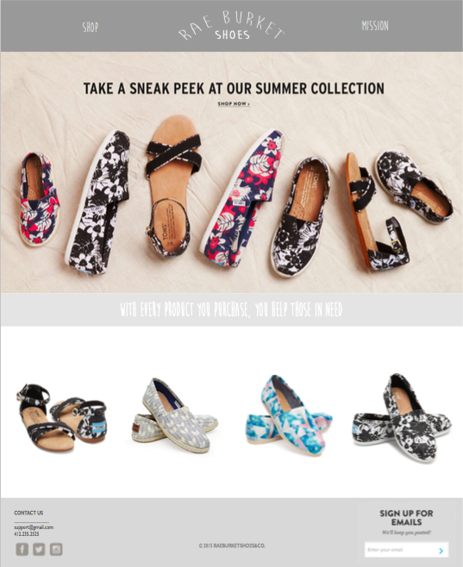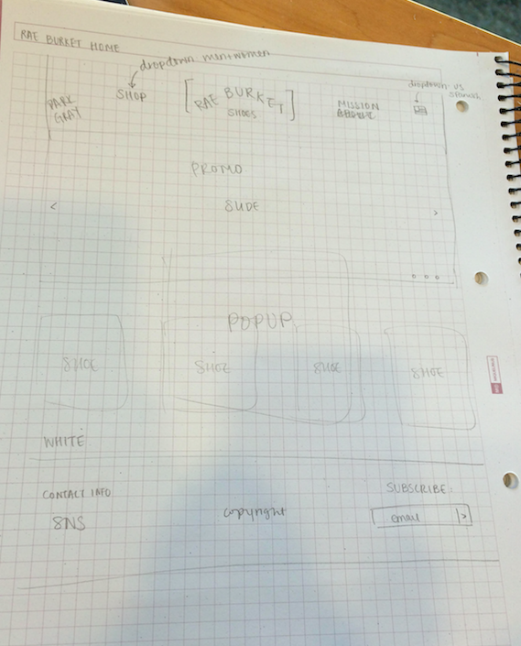

low fidelity high fidelity

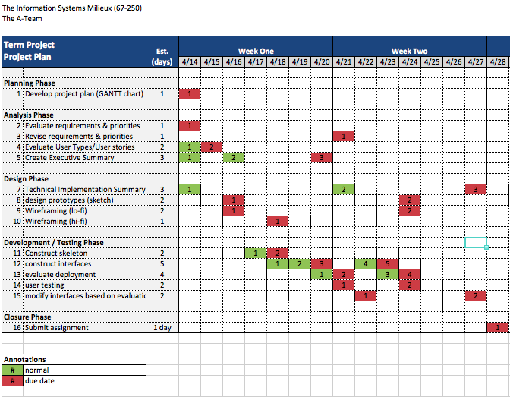**GANTT Chart**

**Successes**

With a clear design in mind, developing the source code for our technical solution was guided towards our final product. There would be frequent checks in design and user testing to confirm the usability of our website. The website features were also very clear in terms of what problems needed to be solved. The final design and functionality of the website fulfills our requirements.

**Improvements**

With more time, our team would include more language options to further the global aspect of the website. It would also be interesting to further the mission page to include interactive information about shoe donations and the impact on local communities.